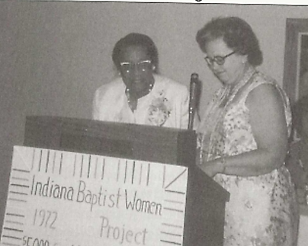ABW Women’s Day Saturday, October 11th, 2025 from 9am – 3pm

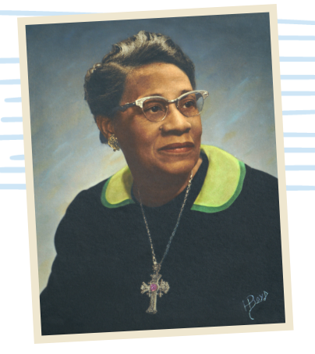 **Sisters of the**

**Solid Rock**

at

**Edna Martin**

**Christian Center**

Leadership and Legacy Campus

2259 Ralston Ave., Indianapolis, IN



*On Christ the solid rock I stand. All other ground is sinking sand*… Mathew 7:24-27

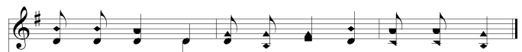

Doors open at 8am for **smiles and hugs**.

We will have an **Upscale Craft/Goodie Bazaar**. Bring your gift list & cash/check.

Also, check out the **EMCC Wish List** on the [**www.ednamartincc.org**](http://www.ednamartincc.org) website

under the **Get Involved** tab. The most-requested items:

Baby & Adult Diapers Sanitizer & Wipes Start collecting now

Soap Tooth Paste & Brush to deliver at

Baby Clothes Food Women’s Day 2025.

Do you have an **EMCC story/experience**? Contact Robin @ 812-606-0132

**\*\*\*\*\*\*\*\*\*\*\*\*\*\*\*\*\*\*\*\*\*\*\*\*\*\*\*\*\*\*\*\*\*\*\*\*\*\*\*\***

Keep the top part to use during your prayer time.

Make $25.00 registration check payable to ‘ABWM of IN.’ Return by September 17th to:

Wendy Shuler @ ABC-IN/KY PO Box 125, Franklin, IN 46131

Name, Phone & Email: _______________________________________________

Address: _________________________________________________________

Church & Association: _______________________________________________

Food Allergies: ____________________________________________________

Emergency Contact- Name & Phone Number: ______________________________