THE BOLICK REPORT


MAY 2026

In January, I had the privilege of traveling to Costa Rica with friends and supporters from Crossroads Baptist Church in Colorado.

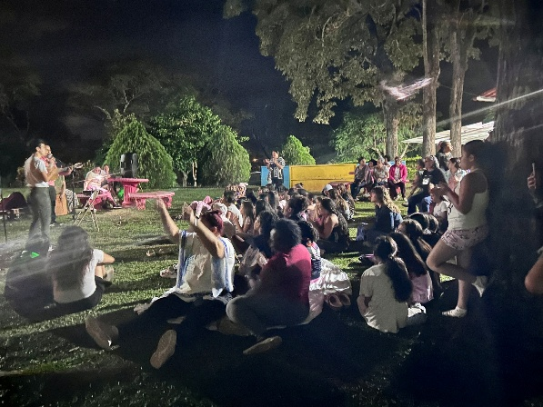
The purpose of our trip was the annual Talita Cumi camp, where girls from across the country gather for several days of learning, joy, and connection. More than one hundred girls filled the campgrounds, bringing energy and excitement with them.

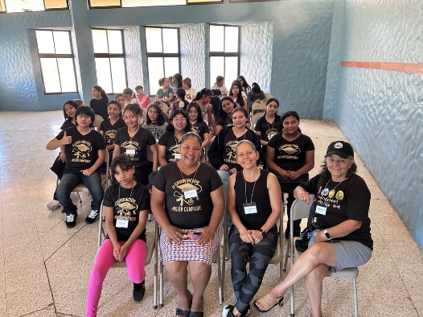
The theme, “Life is an Adventure,” shaped every part of the camp. Through hands-on activities, the girls learned practical and life-giving skills: pitching tents, practicing first aid and mental health first aid, identifying medicinal plants, and distinguishing between harmful and harmless bugs, snakes, and spiders. One favorite activity was setting up tents, where girls worked together, piled inside, and imagined adventures of their own.

In the evenings they gathered around campfires, the girls participated in devotionals that created space for reflection, encouragement, and deeper connection. These moments—simple yet meaningful—are often the ones that stay with them longest.

Research shows that positive, supportive environments can help counter the effects of adversity, fostering resilience, hope, and improved mental and physical health. And for many of these girls, adversity is not something abstract; it is deeply personal.

In the past year, two girls from different clubs experienced sexual assault and became mothers before the age of thirteen. These heartbreaking situations also revealed the strength of the Talita Cumi community. Because they were part of the program, they were not alone. Mentors walked alongside them and their families through medical care and legal processes, ensuring they received support and that justice was pursued. Situations that might otherwise have been hidden were met with courage, advocacy, and care.

Although these young mothers were unable to attend camp this year, they remain active in their clubs, surrounded by a community that continues to support them. Their stories send a powerful message to every girl involved: Talita Cumi is a family. When hardship comes, they will not face it alone.

During this trip, we were joined by Ana Luisa Castro, director of the Talita Cumi program in Nicaragua, where 350 girls are currently participating. I look forward to visiting them in October.

We also explored new partnerships with leaders who have seen the program’s impact and are eager to expand it further. The opportunities ahead are promising.

This is a story of adventure, healing, and hope—and it is still being written.

https://www.internationalministries.org/author/bd-bolick/

